**Advanced Database System Lab**

**PRN: 2020BTECS00023**

**Batch: T5**

**Assignment No. 5**

**Performance tunning for assignment 3:**

**from** **locust** **import** HttpUser, task

**class** **HelloWorldUser**(HttpUser):

@task

**def** hello_world(self):

self.client.get("/hello")

self.client.get("/world")

**Using locust :**

[Locust - A modern load testing framework](https://locust.io/)

An open source load testing tool. Define user behaviour with **Python** code, and swarm your system with millions of simultaneous users. Locust is **a great open source load testing tool for developers written in Python**, since tests can be created as code. It helps teams find bottlenecks and other performance issues.

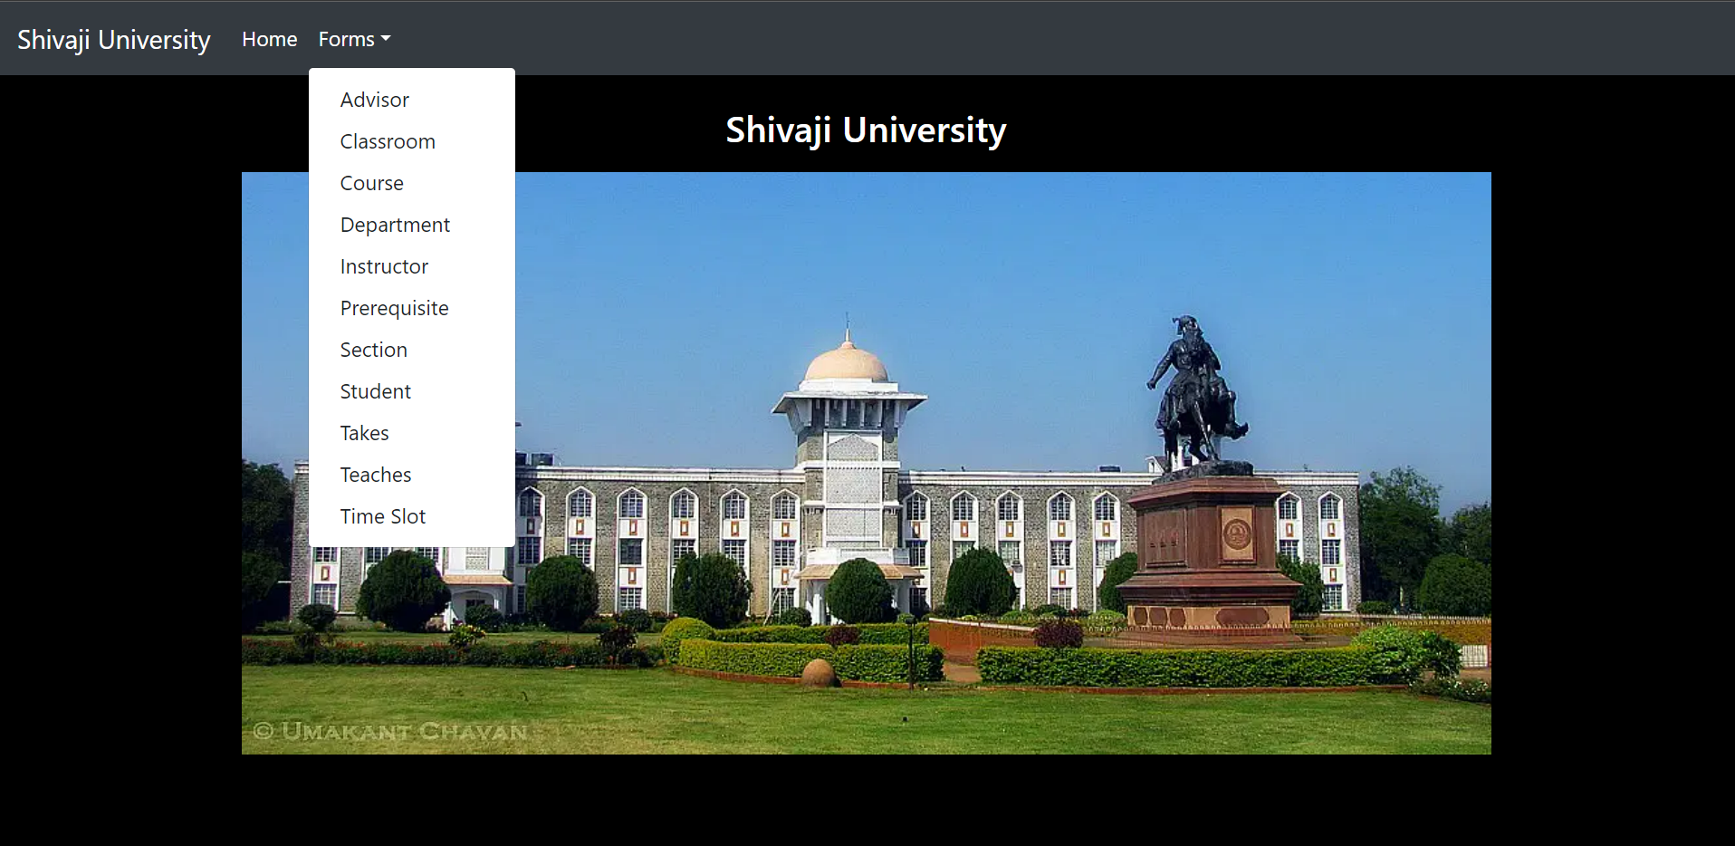

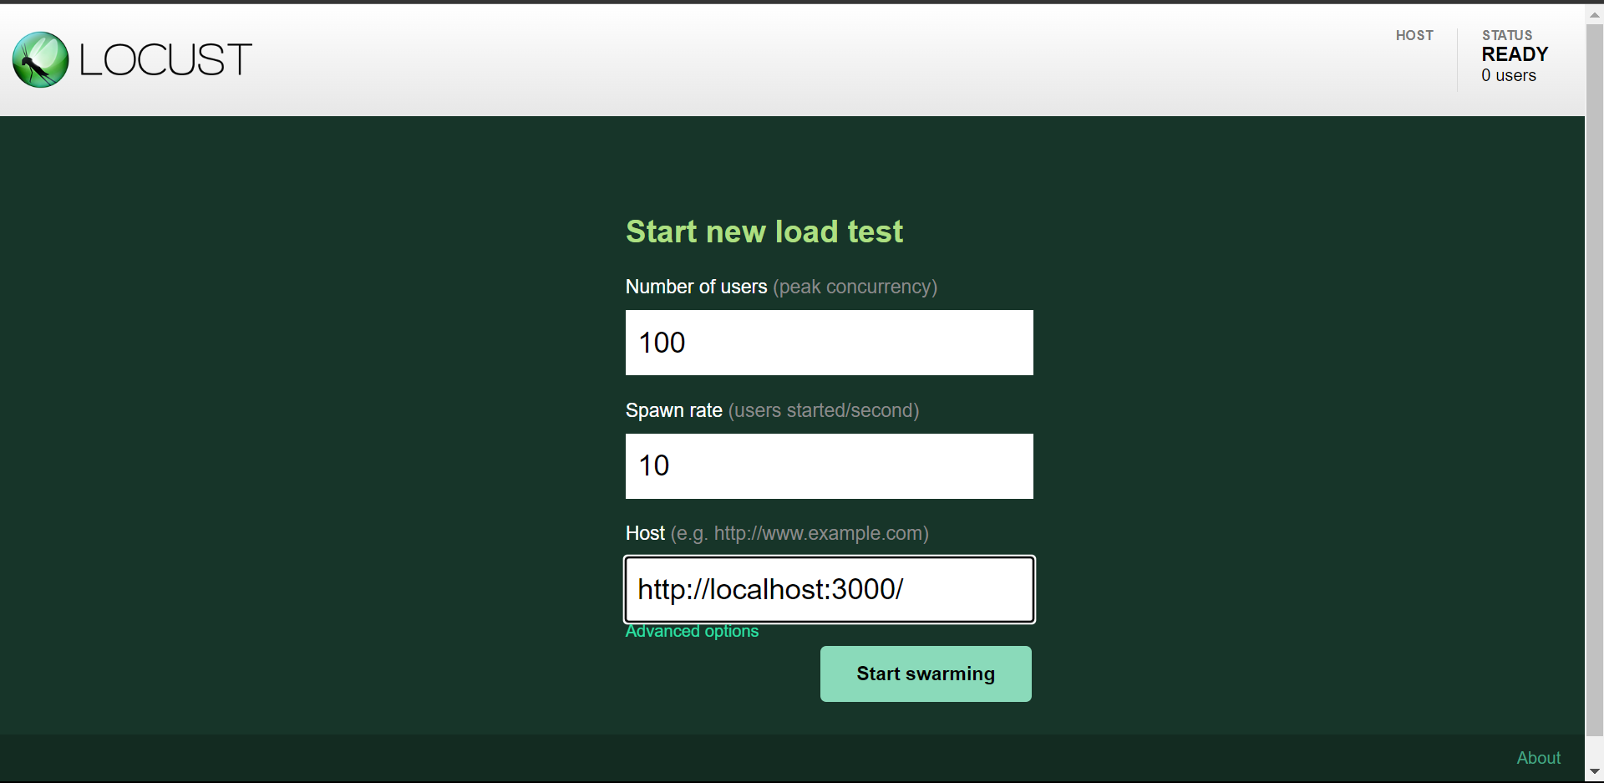

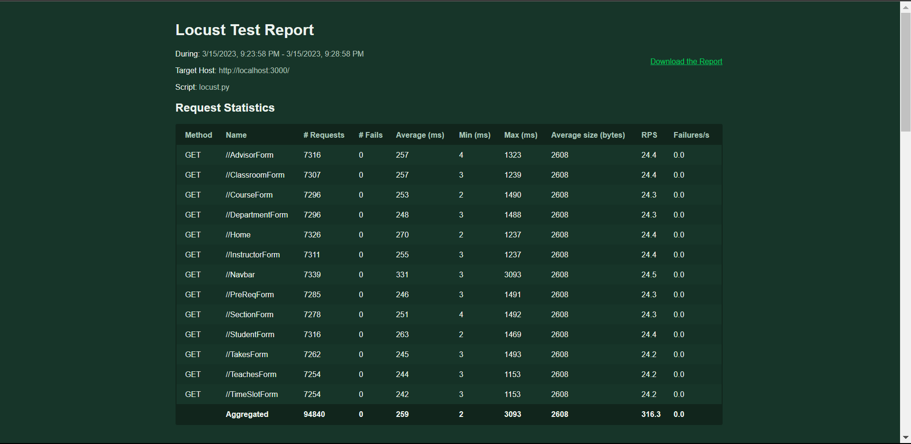

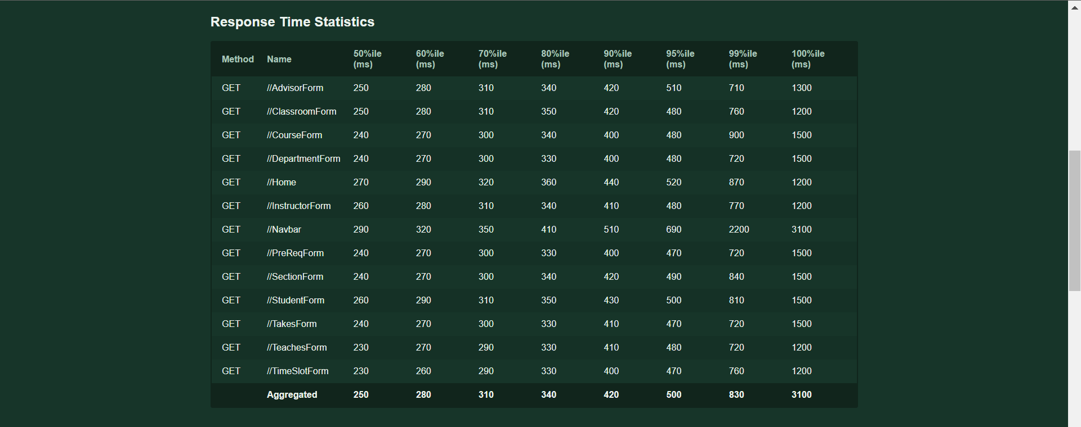

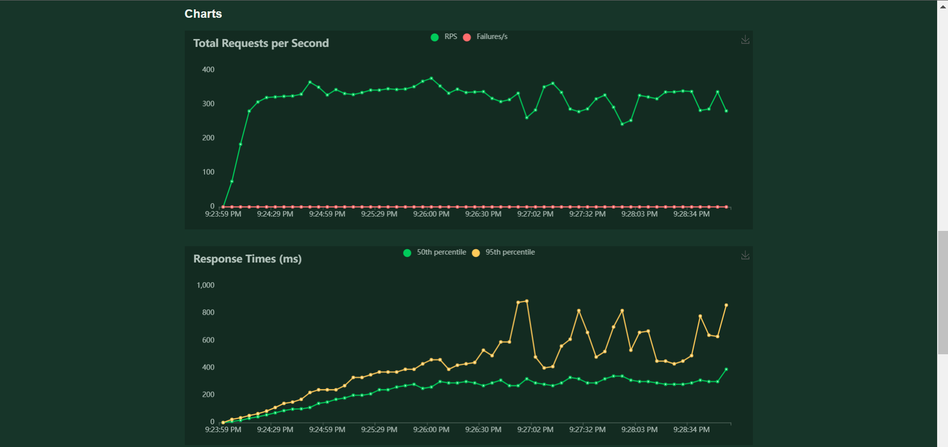

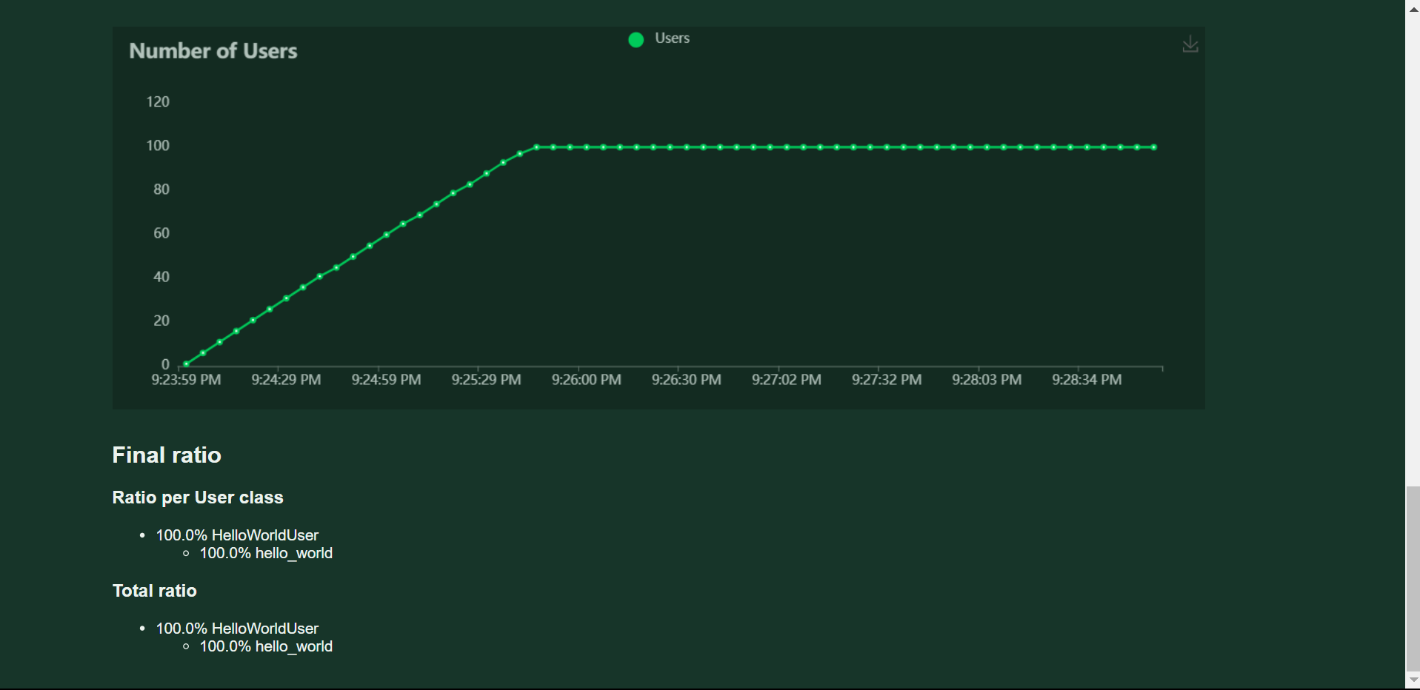

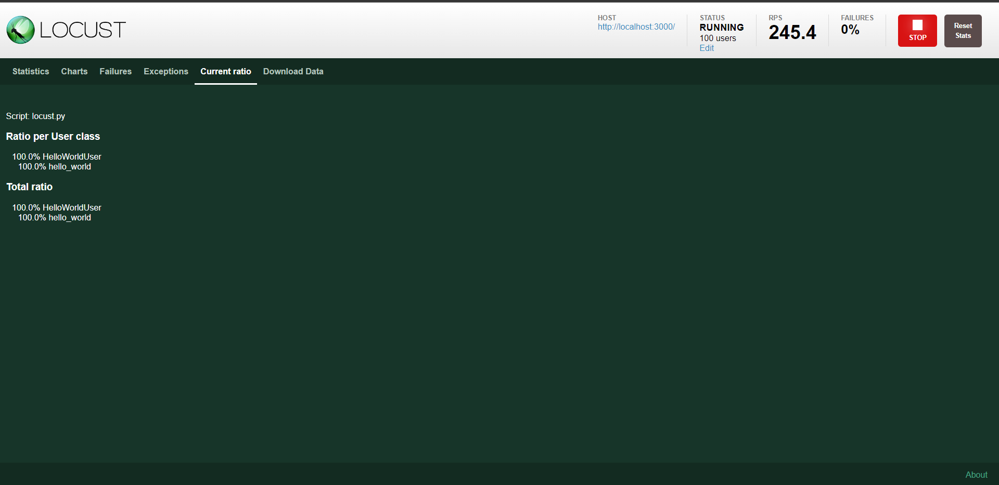

**Performance tunning for assignment 4:**

**Using locust :**

[Locust - A modern load testing framework](https://locust.io/)

An open source load testing tool. Define user behaviour with **Python** code, and swarm your system with millions of simultaneous users. Locust is **a great open source load testing tool for developers written in Python**, since tests can be created as code. It helps teams find bottlenecks and other performance issues.

